Name :

Assignment No 5 - Implement K-Means clustering/ hierarchical clustering on sales_data_sample.csv dataset. Determine the number of clusters using the elbow method.

**Implement K-Means clustering/ hierarchical clustering on sales_data_sample.csv dataset. Determine the number of clusters using the elbow method.**

In [198]:

**import pandas as pd import numpy as np**

**import seaborn as sns**

**import matplotlib.pyplot as plt**

*#Importing the required libraries.*

In [199]:

**from sklearn.cluster import** KMeans, k_means *#For clustering*

**from sklearn.decomposition import** PCA *#Linear Dimensionality reduction.*

In [200]:

df = pd.read_csv("sales_data_sample.csv") *#Loading the dataset.*

# Preprocessing

In [201]:

df.head()

Out[201]:

## ORDERNUMBER QUANTITYORDERED PRICEEACH ORDERLINENUMBER SALES ORDERDATE STATUS QTR_ID MONTH_ID YEAR_ID ... ADDRESSLIN

**1** 10121 34 81.35 5 2765.90 5/7/2003 0:00 Shipped 2 5 2003 ... 59 rue

l'Abba

**3** 10145 45 83.26 6 3746.70 8/25/2003 Shipped 3 8 2003 ... 78934 Hillsi

0:00

5 rows × 25 columns

In [202]:

df.shape

Out[202]: (2823, 25)

In [203]:

df.describe()

Out[203]:

## ORDERNUMBER QUANTITYORDERED PRICEEACH ORDERLINENUMBER SALES QTR_ID MONTH_ID YEAR_ID MSRP

**count** 2823.000000 2823.000000 2823.000000 2823.000000 2823.000000 2823.000000 2823.000000 2823.00000 2823.000000

**mean** 10258.725115 35.092809 83.658544 6.466171 3553.889072 2.717676 7.092455 2003.81509 100.715551

**std** 92.085478 9.741443 20.174277 4.225841 1841.865106 1.203878 3.656633 0.69967 40.187912

**min** 10100.000000 6.000000 26.880000 1.000000 482.130000 1.000000 1.000000 2003.00000 33.000000

**25%** 10180.000000 27.000000 68.860000 3.000000 2203.430000 2.000000 4.000000 2003.00000 68.000000

**50%** 10262.000000 35.000000 95.700000 6.000000 3184.800000 3.000000 8.000000 2004.00000 99.000000

**75%** 10333.500000 43.000000 100.000000 9.000000 4508.000000 4.000000 11.000000 2004.00000 124.000000

**max** 10425.000000 97.000000 100.000000 18.000000 14082.800000 4.000000 12.000000 2005.00000 214.000000

In [204]:

df.info()

<class 'pandas.core.frame.DataFrame'> RangeIndex: 2823 entries, 0 to 2822 Data columns (total 25 columns):

# Column Non-Null Count Dtype

--- ------ -------------- -----

1. ORDERNUMBER 2823 non-null int64
2. QUANTITYORDERED 2823 non-null int64
3. PRICEEACH 2823 non-null float64
4. ORDERLINENUMBER 2823 non-null int64
5. SALES 2823 non-null float64
6. ORDERDATE 2823 non-null object
7. STATUS 2823 non-null object
8. QTR_ID 2823 non-null int64
9. MONTH_ID 2823 non-null int64
10. YEAR_ID 2823 non-null int64
11. PRODUCTLINE 2823 non-null object
12. MSRP 2823 non-null int64
13. PRODUCTCODE 2823 non-null object
14. CUSTOMERNAME 2823 non-null object
15. PHONE 2823 non-null object
16. ADDRESSLINE1 2823 non-null object
17. ADDRESSLINE2 302 non-null object
18. CITY 2823 non-null object
19. STATE 1337 non-null object
20. POSTALCODE 2747 non-null object
21. COUNTRY 2823 non-null object
22. TERRITORY 1749 non-null object
23. CONTACTLASTNAME 2823 non-null object
24. CONTACTFIRSTNAME 2823 non-null object
25. DEALSIZE 2823 non-null object dtypes: float64(2), int64(7), object(16) memory usage: 551.5+ KB

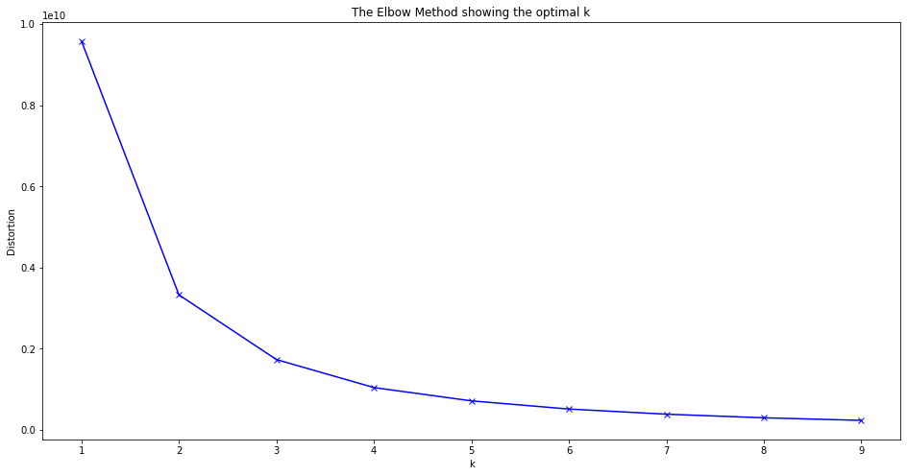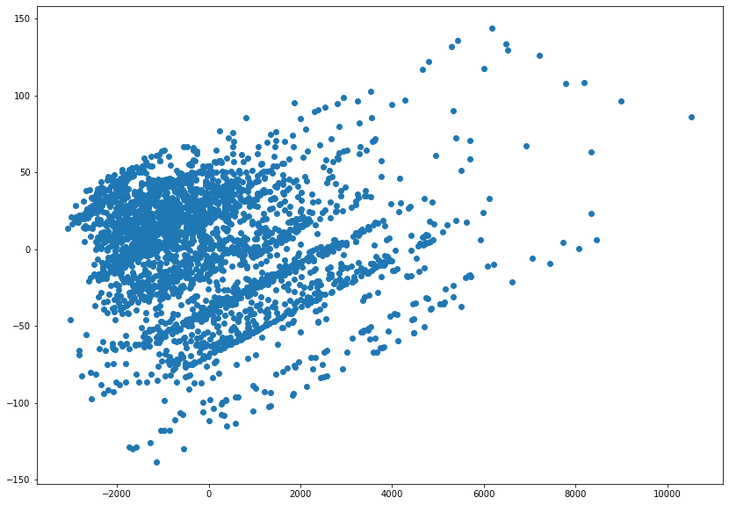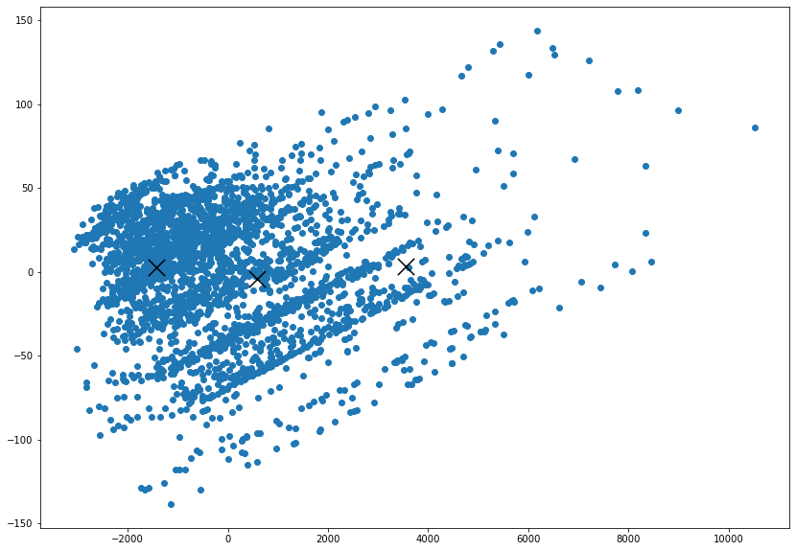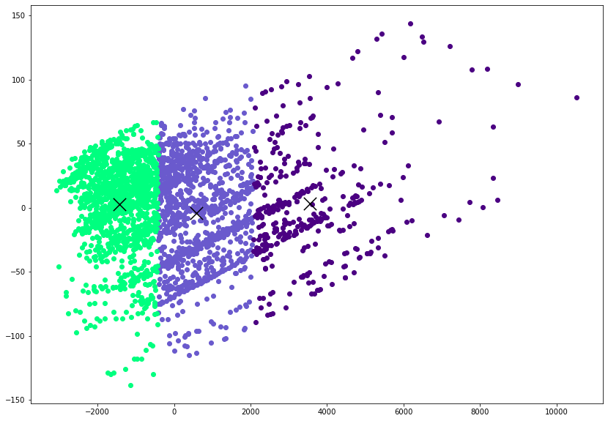

**0**

10107

30 95.70 2 2871.00 2/24/2003 Shipped 1

0:00

2 2003 ... 897 Long Airp

Aven

**2**

10134

41 94.74

27 rue

2 3884.34 7/1/2003 0:00 Shipped 3 7 2003 ... Colonel Pie

A

**4**

10159

49 100.00 14 5205.27 10/10/2003 Shipped 4 10 2003 ... 7734 Strong

0:00

*#Plotting the clusters*

plt.figure(figsize=(14,10))

*#*

*taking the cluster number and first column*

*taking the same cluster number and second*

*column Assigning the color*

plt.scatter(reduced_X[reduced_X['Clusters'] == 0].loc[:,'PCA1'],reduced_X[reduced_X['Clusters'] == 0].loc[:,'PCA2'], color='slateblue')

plt.scatter(reduced_X[reduced_X['Clusters'] == 1].loc[:,'PCA1'],reduced_X[reduced_X['Clusters'] == 1].loc[:,'PCA2'], color='springgreen')

plt.scatter(reduced_X[reduced_X['Clusters'] == 2].loc[:,'PCA1'],reduced_X[reduced_X['Clusters'] == 2].loc[:,'PCA2'], color='indigo')

plt.scatter(reduced_centers[:,0],reduced_centers[:,1],color='black',marker='x',s=300)

In [205]:

df.isnull().sum()

Out[205]: ORDERNUMBER 0

QUANTITYORDERED 0

PRICEEACH 0

ORDERLINENUMBER 0

SALES 0

ORDERDATE 0

STATUS 0

QTR_ID 0

MONTH_ID 0

YEAR_ID 0

PRODUCTLINE 0

MSRP 0

PRODUCTCODE 0

CUSTOMERNAME 0

PHONE 0

ADDRESSLINE1 0

ADDRESSLINE2 2521

CITY 0

STATE 1486

POSTALCODE 76

COUNTRY 0

TERRITORY 1074

CONTACTLASTNAME 0

CONTACTFIRSTNAME 0

DEALSIZE 0

dtype: int64

In [206]:

df.dtypes

Out[206]: ORDERNUMBER int64

QUANTITYORDERED int64

PRICEEACH float64

ORDERLINENUMBER int64

SALES float64

ORDERDATE object

STATUS object

QTR_ID int64

MONTH_ID int64

YEAR_ID int64

PRODUCTLINE object

MSRP int64

PRODUCTCODE object

CUSTOMERNAME object

PHONE object

ADDRESSLINE1 object

ADDRESSLINE2 object

CITY object

STATE object

POSTALCODE object

COUNTRY object

TERRITORY object

CONTACTLASTNAME object CONTACTFIRSTNAME object

DEALSIZE object dtype: object

In [207]:

df_drop = ['ADDRESSLINE1', 'ADDRESSLINE2', 'STATUS','POSTALCODE', 'CITY', 'TERRITORY', 'PHONE', 'STATE', 'CONTACTFI RSTNAME', 'CONTACTLASTNAME', 'CUSTOMERNAME', 'ORDERNUMBER']

df = df.drop(df_drop, axis=1) *#Dropping the categorical uneccessary columns along with columns having null values. C an't fill the null values are there are alot of null values.*

In [208]: df.isnull().sum()

Out[208]: QUANTITYORDERED 0

PRICEEACH 0

ORDERLINENUMBER 0

SALES 0

ORDERDATE 0

QTR_ID 0

MONTH_ID 0

YEAR_ID 0

PRODUCTLINE 0

MSRP 0

PRODUCTCODE 0

COUNTRY 0

DEALSIZE 0

dtype: int64

In [209]: df.dtypes

Out[209]: QUANTITYORDERED int64

PRICEEACH float64

ORDERLINENUMBER int64

SALES float64

ORDERDATE object

QTR_ID int64

MONTH_ID int64

YEAR_ID int64

PRODUCTLINE object

MSRP int64

PRODUCTCODE object

COUNTRY object

DEALSIZE object dtype: object

In [ ]:

*# Checking the categorical columns.*

In [210]:

df['COUNTRY'].unique()

Out[210]: array(['USA', 'France', 'Norway', 'Australia', 'Finland', 'Austria', 'UK', 'Spain', 'Sweden', 'Singapore', 'Canada', 'Japan', 'Italy', 'Denmark', 'Belgium', 'Philippines', 'Germany', 'Switzerland', 'Ireland'], dtype=object)

In [211]:

df['PRODUCTLINE'].unique()

Out[211]: array(['Motorcycles', 'Classic Cars', 'Trucks and Buses', 'Vintage Cars', 'Planes', 'Ships', 'Trains'], dtype=object)

In [212]:

df['DEALSIZE'].unique()

Out[212]: array(['Small', 'Medium', 'Large'], dtype=object)

In [213]:

productline = pd.get_dummies(df['PRODUCTLINE']) *#Converting the categorical columns.*

Dealsize = pd.get_dummies(df['DEALSIZE'])

In [214]:

df = pd.concat([df,productline,Dealsize], axis = 1)

In [215]:

df_drop = ['COUNTRY','PRODUCTLINE','DEALSIZE'] *#Dropping Country too as there are alot of countries.*

df = df.drop(df_drop, axis=1)

In [216]:

df['PRODUCTCODE'] = pd.Categorical(df['PRODUCTCODE']).codes *#Converting the datatype.*

In [217]:

df.drop('ORDERDATE', axis=1, inplace=**True**) *#Dropping the Orderdate as Month is already included.*

In [218]:

df.dtypes *#All the datatypes are converted into numeric*

Out[218]: QUANTITYORDERED int64

PRICEEACH float64

ORDERLINENUMBER int64

SALES float64

QTR_ID int64

MONTH_ID int64

YEAR_ID int64

MSRP int64

PRODUCTCODE int8

Classic Cars uint8

Motorcycles uint8

Planes uint8

Ships uint8

Trains uint8

Trucks and Buses uint8

Vintage Cars uint8

Large uint8

Medium uint8

Small uint8

dtype: object

# Plotting the Elbow Plot to determine the number of clusters.

In [219]:

distortions = [] *# Within Cluster Sum of Squares from the centroid*

K = range(1,10)

**for** k **in** K:

kmeanModel = KMeans(n_clusters=k) kmeanModel.fit(df)

distortions.append(kmeanModel.inertia_) *#Appeding the intertia to the Distortions*

In [220]:

plt.figure(figsize=(16,8)) plt.plot(K, distortions, 'bx-') plt.xlabel('k') plt.ylabel('Distortion')

plt.title('The Elbow Method showing the optimal k') plt.show()

In [221]:

**As the number of k increases Inertia decreases.**

**Observations: A Elbow can be observed at 3 and after that the curve decreases gradually.**

X_train = df.values *#Returns a numpy array.*

In [222]:

X_train.shape

Out[222]: (2823, 19)

In [223]:

model = KMeans(n_clusters=3,random_state=2) *#Number of cluster = 3*

model = model.fit(X_train) *#Fitting the values to create a model.*

predictions = model.predict(X_train) *#Predicting the cluster values (0,1,or 2)*

In [225]:

unique,counts = np.unique(predictions,return_counts=**True**)

In [226]:

counts = counts.reshape(1,3)

In [227]:

counts_df = pd.DataFrame(counts,columns=['Cluster1','Cluster2','Cluster3'])

In [228]:

counts_df.head()

Out[228]:

**Cluster1 Cluster2 Cluster3**

**0** 1083 1367 373

# Visualization

In [229]:

pca = PCA(n_components=2) *#Converting all the features into 2 columns to make it easy to visualize using Principal C Omponent Analysis.*

In [230]:

reduced_X = pd.DataFrame(pca.fit_transform(X_train),columns=['PCA1','PCA2']) *#Creating a DataFrame.*

In [231]:

reduced_X.head()

Out[231]:

## PCA1 PCA2

**0** -682.488323 -42.819535

**1** -787.665502 -41.694991

**2** 330.732170 -26.481208

**3** 193.040232 -26.285766

**4** 1651.532874 -6.891196

In [232]:

*#Plotting the normal Scatter Plot* plt.figure(figsize=(14,10)) plt.scatter(reduced_X['PCA1'],reduced_X['PCA2'])

Out[232]: <matplotlib.collections.PathCollection at 0x218dc747880>

In [233]:

model.cluster_centers_ *#Finding the centriods. (3 Centriods in total. Each Array contains a centroids for particular feature )*

Out[233]: array([[ 3.72031394e+01, 9.52120960e+01, 6.44967682e+00, 4.13868425e+03, 2.72022161e+00, 7.09879963e+00,

2.00379409e+03, 1.13248384e+02, 5.04469067e+01,

3.74884580e-01, 1.15420129e-01, 9.41828255e-02,

8.21791320e-02, 1.84672207e-02, 1.16343490e-01,

1.98522622e-01, 2.08166817e-17, 1.00000000e+00,

-6.66133815e-16],

[ 3.08302853e+01, 7.00755230e+01, 6.67300658e+00, 2.12409474e+03, 2.71762985e+00, 7.09509876e+00,

2.00381127e+03, 7.84784199e+01, 6.24871982e+01,

2.64813460e-01, 1.21433797e-01, 1.29480614e-01,

1.00219459e-01, 3.87710315e-02, 9.21726408e-02,

2.53108998e-01, 6.93889390e-18, 6.21799561e-02,

9.37820044e-01],

[ 4.45871314e+01, 9.98931099e+01, 5.75603217e+00, 7.09596863e+03, 2.71045576e+00, 7.06434316e+00,

2.00389008e+03, 1.45823056e+02, 3.14959786e+01,

5.33512064e-01, 1.07238606e-01, 7.23860590e-02,

2.14477212e-02, 1.07238606e-02, 1.31367292e-01,

1.23324397e-01, 4.20911528e-01, 5.79088472e-01,

5.55111512e-17]])

In [234]:

reduced_centers = pca.transform(model.cluster_centers_) *#Transforming the centroids into 3 in x and y coordinates*

In [235]:

reduced_centers

Out[235]: array([[ 5.84994044e+02, -4.36786931e+00],

[-1.43005891e+03, 2.60041009e+00], [ 3.54247180e+03, 3.15185487e+00]])

In [236]:

plt.figure(figsize=(14,10)) plt.scatter(reduced_X['PCA1'],reduced_X['PCA2'])

plt.scatter(reduced_centers[:,0],reduced_centers[:,1],color='black',marker='x',s=300) *#Plotting the centriods*

Out[236]: <matplotlib.collections.PathCollection at 0x218deb6e220>

In [237]:

reduced_X['Clusters'] = predictions *#Adding the Clusters to the reduced dataframe.*

In [238]:

reduced_X.head()

Out[238]:

## PCA1 PCA2 Clusters

**0** -682.488323 -42.819535 1

**1** -787.665502 -41.694991 1

**2** 330.732170 -26.481208 0

**3** 193.040232 -26.285766 0

**4** 1651.532874 -6.891196 0

In [239]:

Out[239]: <matplotlib.collections.PathCollection at 0x218dce9e1f0>

In [ ]: